MKC75 Tri-mode Keyboard Specifications

## Keyboard Overview

* Full CNC high-end wireless mechanical keyboard.
* In the top right corner of the keyboard, a Rotary Knob or a Light Sign with five LEDs can be installed.
* 81-key layout, streamlined design, significantly saving desktop space.
* Compatibility with systems: Windows XP, Win7, Win8, Win10, Win11, macOS, Android.
* Different driver for ASIN and ISO layout, driver language switchable between Chinese and English

## Specifications

* Supports different versions of the Rotary Knob and Light Sign daughterboards. (Utilizes a 14-pin socket.)
* Supports layered customization of the Fn key through the driver. Enables FN key mapping functionality, allowing customization of both regular and compatible keys.
* Supports 2.4G, Bluetooth, and wired modes, with combination keys to switch between modes.
* Supports switching between Win/Mac systems.
* The position of the Esc key features a charging indicator, which can be turned off using a key combination.
* The two LED lights for CAPS support different layout versions as needed.
* The power switch is a toggle switch.

## Function Key Diagram

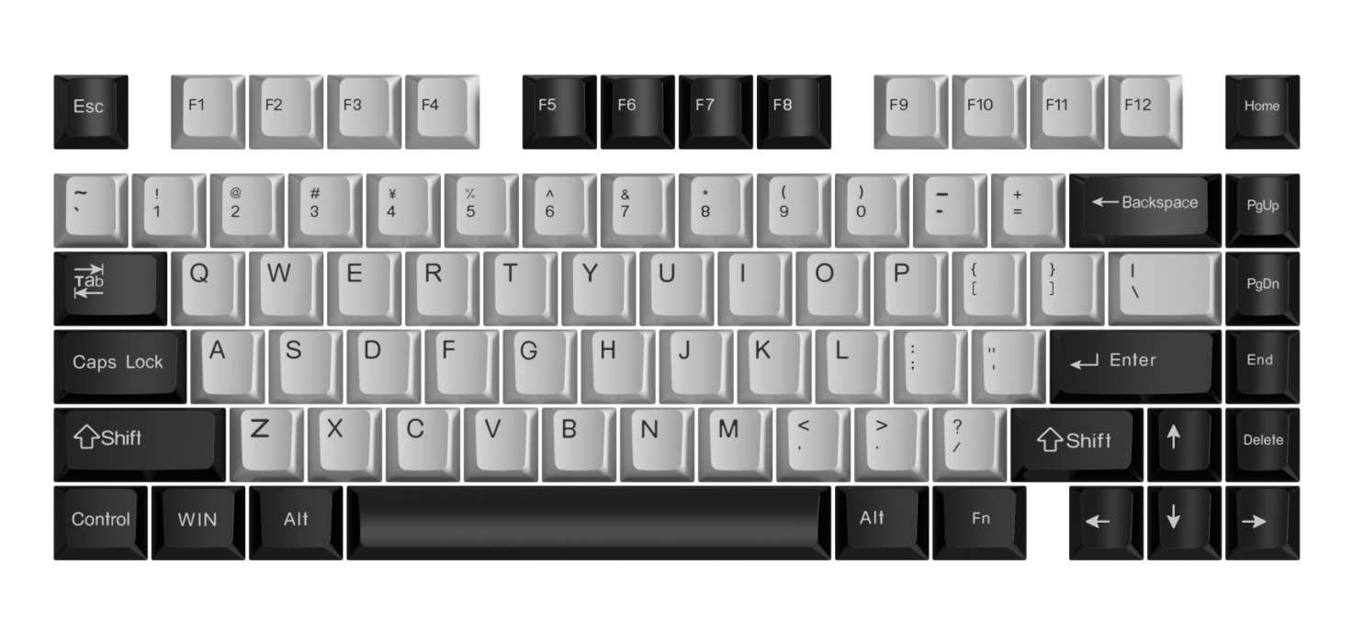

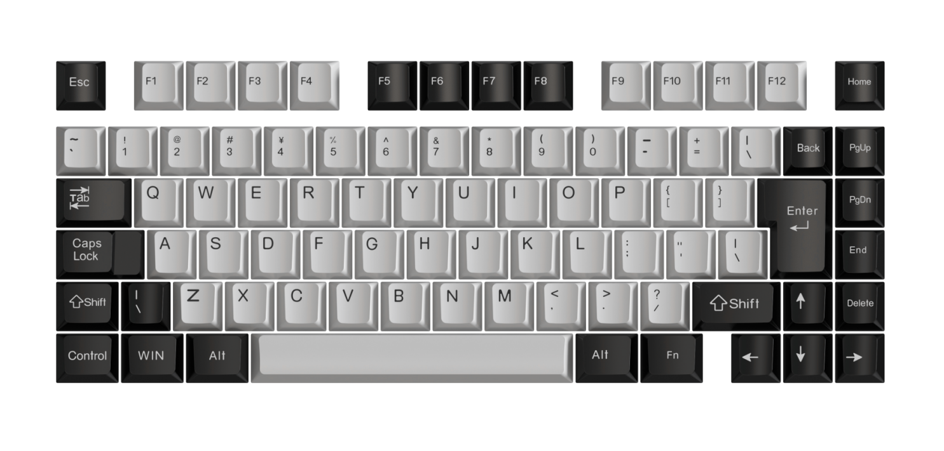

## **Multimedia Functions**

**Rotary Mode Functions:**

* Long press the rotary knob to switch between scroll mode and volume mode (Default is volume mode).
* Volume mode: short press= mute, clockwise= volume up, counterclockwise= volume down.
* Scroll mode: short press= Enter key, clockwise= scrolling down the page, counterclockwise= scrolling up the page.

**Light Functions:**

* Supports 10 LED lighting effects (Neon, Breathing, Marquee, Red, Blue, Green, Yellow, Orange, Purple, White), with an additional mode to turn off the lighting.

## **Indicator Light Functions**

* ESC key with LED Charging Indicator: The red light is on during charging, and it turns off when fully charged. Users have the option to turn off the indicator light through a combination of keys.
* CAPS Lock Key with Two LED Lights: Remains continuously illuminated in white when CAPS Lock is activated.

## Tri-mode Layer Functions

* Long-pressing Fn+ Q= Switch to 2.4G Mode. During pairing, the CAPS Lock indicator flashes rapidly in green, and after successful connection, it blinks slowly before turning off.
* Long-pressing Fn+ W= Switch to Bluetooth Mode 1. During pairing, the CAPS Lock indicator flashes rapidly in blue, and after successful connection, it blinks slowly before turning off.
* Long-pressing Fn+ E= Switch to Bluetooth Mode 2. During pairing, the CAPS Lock indicator flashes rapidly in orange, and after successful connection, it blinks slowly before turning off.
* Long-pressing Fn+ R= Switch to Bluetooth Mode 3. During pairing, the CAPS Lock indicator flashes rapidly in purple, and after successful connection, it blinks slowly before turning off.
* Pressing Fn+ T= Switch to the Wired mode. When USB is not connected, the white indicator flashes rapidly, and when connected, the indicator turns off.
* Pressing Fn+ A= Switch to the Windows system. The Caps Lock indicator blinks slowly in red three times.
* Pressing Fn+ S= Switch to the Mac system. The Caps Lock indicator blinks slowly in yellow three times.

*\*Note: If there is no connection within 1 minute during 2.4G and Bluetooth pairing, the indicator turns off, and the pairing mode is exited. When attempting to reconnect and no connection is established, the indicator blinks slowly continuously.*

## **Driver Requirements**

The driver is version 2.0 with FN layered customization settings.

## **Fn Combination Key Functions**

**Light Adjustment:**

* Fn+ Up Arrow= Increase light brightness; Fn+ Down Arrow= Decrease light brightness. (5 levels of brightness adjustment)
* Fn+ Left Arrow= Decrease light speed; Fn+ Right Arrow= Increase light speed. (5 levels of speed adjustment)
* Fn+ Space= Light effect adjustment.
* Fn+ R_Shift= Light color adjustment (effective for breathing light effect).

*\*Note: When light brightness/speed is at its maximum/minimum, the Esc key flashes white three times.*

**Multimedia Combination Key Functions:**

|  |  |
| --- | --- |
| **Windows** | **macOS system** |
| Fn+ Esc (Long Press)= Restore to Factory Settings | Fn+ Esc (Long Press)= Restore to Factory Settings |
| FN+ F1= My Computer | F1= Decrease Screen Brightness |
| FN+ F2= Home | F2= Increase Screen Brightness |
| FN+ F3= Email | F3= Task Switching Window |
| FN+ F4= Calculator | F4= Show Desktop |
| FN+ F5= Media Player | / |
| FN+ F6= Stop | / |
| FN+ F7= Previous Track | F7= Previous Track |
| FN+ F8= Play/Pause | F8= Play/Pause |
| FN+ F9= Next Track | F9= Next Track |
| FN+ F10= Mute | F10= Mute |
| FN+ F11= Volume Down | F11= Volume Down |
| FN+ F12= Volume Up | F12= Volume Up |

*Note: This manual is for reference only, actual results may vary depending on the physical product.*